ESC
European society of cardiology

Europace (2023) 25, 1237–1248
https://doi.org/10.1093/europace/euad044

EHRA DOCUMENT

EHRA clinical consensus statement

on conduction system pacing implantation: executive summary. Endorsed by the

Asia-Pacific Heart Rhythm Society (APHRS), Canadian Heart Rhythm Society (CHRS) and Latin-American Heart Rhythm

Society (LAHRS)
Haran Burri 1*, Marek Jastrzebski2, Óscar Cano3, Karol Čurila4, Jan de Pooter5, Weijian Huang6, Carsten Israel7, Jacqueline Joza8, Jorge Romero9, Kevin Vernooy10, Pugazhendhi Vijayaraman11, Zachary Whinnett12, and Francesco Zanon13
1Cardiac Pacing Unit, University Hospital of Geneva, Geneva, Switzerland; 2First Department of Cardiology and Electrocardiology and Arterial Hypertension, Jagiellonian University, Krakow, Poland; 3Hospital Universitario y Politecnico La Fe, ValenciamSpain and Centro de Investigaciones Biomédicas en RED en Enfermedades Cardiovasculares (CIBERCV), Madrid, Spain;
4Cardiocenter, Third Faculty of Medicine, Charles University and University Hospital, Kralovske Vinohrady, Prague, Czech Republic; 5Heart Centre, University Hospital Ghent, Ghent, Belgium; 6The First Affiliated Hospital of Wenzhou Medical University, Wenzhou, China; 7Bethel-Clinic, Bielefeld, Germany; 8Department of Medicine, McGill University Health Center, Montreal, Canada; 9Brigham and Women’s Hospital, Boston, Massachusetts, United States of America; 10Department of Cardiology, Cardiovascular Research Institute Maastricht (CARIM), Maastricht University Medical Center, Maastricht, The Netherlands; 11Geisinger Wyoming Valley Medical Center, Wilkes-Barre, PA, United States of America; 12National Heart and Lung institute, Imperial College London, United Kingdom; and 13Arrhythmia and Electrophysiology Unit, Santa Maria della Misericordia General Hospital, Rovigo, Italy
Received 3 February 2023; accepted after revision 3 February 2023
Abstract Conduction system pacing (CSP) has emerged as a more physiological alternative to right ventricular pacing and is also being
used in selected cases for cardiac resynchronization therapy. His bundle pacing was first introduced over two decades ago and its use has risen over the last years with the advent of tools which have facilitated implantation. Left bundle branch area pacing is more recent but its adoption is growing fast due to a wider target area and excellent electrical parameters. Nevertheless, as with any intervention, proper technique is a prerequisite for safe and effective delivery of therapy. This document aims to standardize the procedure and to provide a framework for physicians who wish to start CSP implantation, or who wish to improve their technique. A synopsis is provided in this print edition of EP-Europace. The full document may be consulted online, and a ‘Key Messages’ App can be downloaded from the EHRA website.
Keywords Conduction system pacing • His bundle pacing • Left bundle branch area pacing • Device implantation

Abbreviations
A atrial
AVN atrioventricular node
COI current of injury
CS coronary sinus
CSP conduction system pacing

DSP
ECG
EGM
HBP
iso
LAO
LAFP

deep septal pacing electrocardiogram electrogram
His bundle pacing isoelectric
left anterior oblique left anterior fascicle

pacing

* Corresponding author. Tel: 0041 22 372 72 29. E-mail address: haran.burri@hcuge.ch
© The Author(s) 2023. Published by Oxford University Press on behalf of the European Society of Cardiology.
This is an Open Access article distributed under the terms of the Creative Commons Attribution-NonCommercial License (https://creativecommons.org/licenses/by-nc/4.0/), which permits non-commercial re-use, distribution, and reproduction in any medium, provided the original work is properly cited. For commercial re-use, please contact journals.permissions@oup.com

LBBAP LBB  LBBP  LFP  LPFP  LSFP  LVSP  LV  RAO  RBB  RBBP RV  RWPT SDL  Definitions | left bundle branch area pacing  left bundle branch  left bundle branch pacing left fascicular pacing  left posterior fascicle pacing left septal fascicle pacing  left ventricular septal pacing  left ventricular  right anterior oblique right bundle branch  right bundle branch pacing right ventricle  R-wave peak time stylet-driven lead
The different entities of CSP, and related forms of pacing, are shown in Figure 1.
Conduction system pacing: direct activation of the conduction system of the heart by the pacing stimulus.
His bundle pacing: direct capture of the atrioventricular bundle with activation of all of its fibres. The pacing lead may be located prox- imally on the atrial aspect of the tricuspid valve, or distally on the

ventricular aspect. The His bundle potential to QRS interval at the pa- cing site is usually ≥ 35 ms In some patients, the distal His bundle may be paced from deep in the septum.
Right bundle branch pacing: direct capture of the proximal RBB (usually observed when the distal His bundle is targeted).2 Criteria are outlined in. Direct capture of the distal RBB is rare.
Left bundle branch pacing: capture of the pre-divisional LBB with activation of all of its fascicles. Pacing lead position deep in the interven- tricular septum, ~1–2 cm from the distal His bundle potential (or the tricuspid valve summit), LBB potential to QRS interval 34–25 ms, nor- mal QRS axis and fulfilled criteria for conduction system capture.
Left fascicular pacing: capture of one of the LBB fascicles or its distal arborization. Potential to QRS interval < 25 ms, often with an paced QRS axis, with presence of criteria for conduction system capture. Includes LAFP, LSPF and LPFP.
Left ventricular septal pacing: capture of the left side of the interventricular septum (basal to mid-septal area) without direct ac- tivation of the left conduction system. Terminal R-wave in V1 and absence of criteria for conduction system capture. The left-sided conduction system may be rapidly engaged retrogradely despite lack of direct capture.
Left bundle branch area pacing: capture of the subendocardial area on the left side of the interventricular septum, with or without sim- ultaneous conduction system capture (terminal R-wave in lead V1 may be absent in some cases) and includes LBBP, LFP and LVSP.

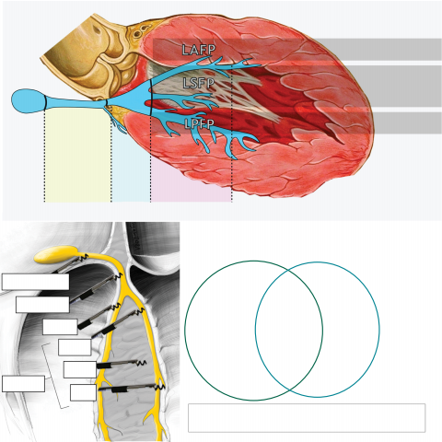
Paced QRS
morphology
II/III +
II +/iso
III iso/-
II/III -

HBP LBBP LFP

55 ms 35 ms 25 ms 0 ms Potential - QRS interval

CSP LBBAP

Proximal HBP
Distal HBP
LBBP
HBP
LVSP
RBBP
LFP
RBBP

DSP
LBBP
LVSP
LBBAP
LFP

CSP: conduction system pacing; DSP: deep septal pacing; HBP: His bundle pacing
LBBAP: left bundle branch area pacing; LBBP: left bundle branch pacing
LFP: left fascicular pacing; RBBP: right bundle branch pacing

Figure 1 Synopsis of CSP and related pacing modalities. Modified with permission from Filip Plesinger and from Jastrzebski et al.1

Deep septal pacing: lead positioned deep in the septum but does not reach the left ventricular subendocardial area. Differentiated from LBBAP by lack of terminal R-wave in lead V1 and no features of left con- duction system capture.

His bundle pacing lead implantation

Key steps
(1) Locate the His bundle using unipolar mapping by the pacing lead in the RAO 20–30° view. Ideally, a sharp near-field His potential is visualized, with absent or small far-field atrial electrogram and a lar- ger ventricular electrogram. Locating the His bundle by pacemapping at 5 V/1 ms is useful if a His potential is not visualized.
(2) Screw the lead while stabilizing the guiding catheter. Torque build-up should be felt, with rebound upon release of the lead (the number of lead rotations is variable).

(3) Check the morphology of the His potential, which ideally should show a COI and/or a negative potential. Presence of His capture may be briefly checked (e.g. at 5 and 2 V/0.5 ms).
(4) Withdraw the guiding catheter by 5–8 cm to expose the lead.
(5) Test for stability by gently pulling, or pushing the lead to give a ‘U’ form with two additional rotations of the lead to test for changes in capture threshold or reduction His potential amplitude.
(6) Perform threshold testing by carefully analyzing the ECG for His capture (see Figure 2). A His threshold of ≤ 1.5 V/0.5 ms is opti- mal but up to 2.5 V @0.5 ms may be acceptable. Presence of COI may initially result in high thresholds, which may improve over the following minutes. Bipolar sensing should ideally be >
2 mV (low sensing thresholds may require a backup ventricular lead for sensing).
(7) Implant additional leads as required.
(8) Check His thresholds again before slitting.
(9) Slit guiding catheter.
(10) Adjust lead slack and perform final threshold test.

ECG confirmation of His bundle capture
Transitions in QRS morphology with pacing output Morphological features
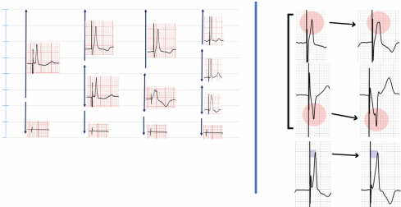
Output (V/0.5ms)
8
7
6
5
4
3
2
1
0
NS-HBP Myo
NS-HBPcorr+
NS-HBP
plateau
I
and/or
S-HBP
V4-6
S-HBPcorr–
notch
LOC
LOC
LOC
<100ms RWPT >100ms
V6
NS-HBP = non-selective His bundle pacing S-HBP = selective His bundle pacing
Myo = myocardial-only capture corr+/– = with/without correction
LOC = loss of capture
His
Myocardium
Bundle branch
A B
S-HBPcorr+
Thresholds
NS-HBP
S-HBP
Myo
LOC
C
D
Figure 2 ECG transitions with decrementing pacing output, and morphological features to diagnose his bundle capture. Adapted with permission from Burri et al.3

Left bundle branch area pacing

Key steps
(1) Locate the His bundle or the tricuspid annulus summit in the RAO 20–30° fluoroscopic view using unipolar sensing by the pacing lead. Alternatively, contrast injection via the guiding catheter may be used to delineate the tricuspid valve. Store reference image.
(2) Advance the guiding catheter into the right ventricle at 15–20 mm from the His bundle towards the apex (see Figure 3). The lead should be kept within the guiding catheter to avoid snagging of the screw on the tricuspid valve. Apply slight counterclockwise torque to the guid- ing catheter to position it against the septum and push out the lead by a few millimetres. Presence of a COI of the ventricular signal in- dicates good contact.
(3) Pacemap, and adjust lead position if necessary, aiming at discordant QRS in leads II (predominantly positive or equiphasic) and III (equi- phasic or predominantly/completely negative). A W’ pattern with a notch at the nadir of V1 may be observed (although this is not mandatory).
(4) Shift to the LAO 30–40° view. The guiding catheter should orient the lead at 10–40° superiorly to the horizontal plane in order to be perpendicular to the septal curve (see Figure 4). Contrast

injection via the guiding catheter may optionally be performed to de- lineate the septum. Adjust orientation if necessary.
(5) Rapidly rotate the lead body to screw in the lead, while applying some forward push and maintaining the guiding catheter in pos- ition. Continuous screening allows to check coaxial orientation between the guiding catheter and the lead and evaluates pro- gression of the lead in the septum. Ideally, lead depth should be monitored by continuous pacing performed while screwing the lead (via the stylet of SDLs, or using a tool designed for this purpose for lumenless leads). Entanglement, drill, or screw- driver effects should be recognized (Figure 5). Lead depth should be monitored using the parameters shown in Table 1 and screw- ing should be continued utile the paced QRS morphology is sat- isfactory (see Figure 6). Lead course may also be checked in RAO.
(6) Test lead stability by gently pulling on the lead, or by withdrawing the delivery catheter and pushing the lead to form an α-shaped loop.
(7) Perform threshold tests.
(8) Implant additional leads if required
(9) Check paced QRS morphology and thresholds before slitting the guiding catheter
(10) Adjust slack and perform a final check of paced QRS morphology and thresholds.
Device configurations for CSP lead connections are shown in Figure 7.

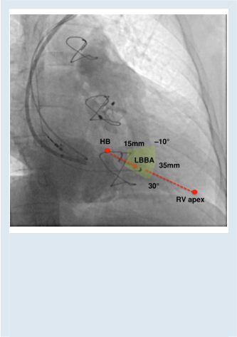

Figure 3 Insertion site for LBBA pacing. In a 30° RAO view, con- trast is injected through a sheath delineating right atrial and ventricular anatomy as well as tricuspid valve leaflets. The summit of the tricuspid annulus indicates the approximate His bundle position. The red arrow indicates an imaginary line that connects the tricuspid annulus summit/ His bundle with the RV apex, which serves as a guide for placing the lead. Successful pacing sites can be localized within a sector (indicated in yellow) located 15–35 mm away from the tricuspid annulus summit and at an angle of -10° to 30°, as described by Liu et al.16

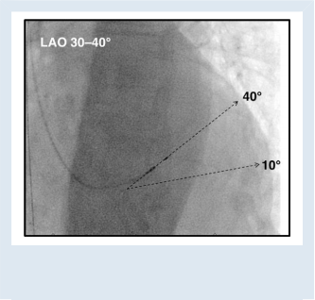

Figure 4 Left panel: LAO view for orienting the lead 10–40° (most often 20–30°) with respect to the horizontal plane for perpendicular septal penetration.

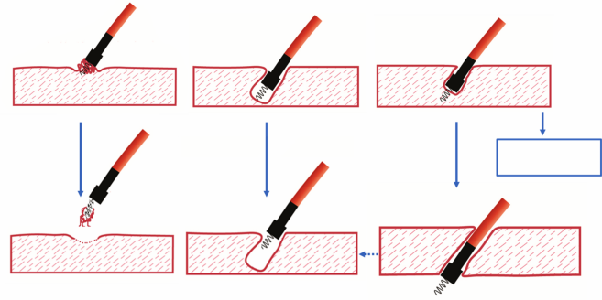

Figure 5 Lead behaviour during penetration of the septum with LBBAP. Both drill and screwdriver effects can result in perforation.
Entanglement Drill Screwdriver
Desired depth and stable
Micro-or macro- Partial or overt
dislodgment
Lead damage or entrapment

perforation

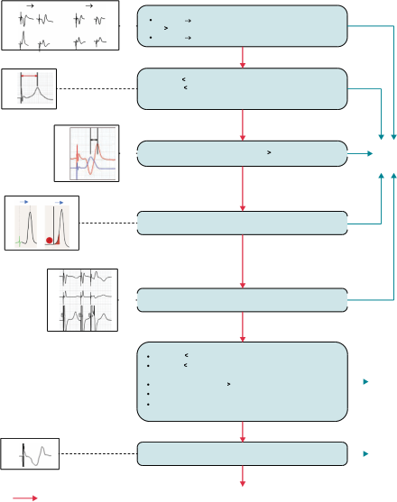
QRS transition to LVSP or s-LBBP @ threshold test
LVSP
sLBBP
nsLBBP V1
nsLBBP V1
ns-LBBP s-LBBP : splitting of EGM and/or V1RWPT ↑ by 10 ms
ns-LBBP LVSP : V6RWPT↑ by ≥ 15 ms
V6
V6

V6RWPT 75 ms (native narrow QRS or isolated RBBB)
V6RWPT 80 ms (LBBB, IVCD RBBB+fascicular block,
wide escape rhythm, asystole)
V6

V6-V1 interpeak interval 44 ms
LBBP
V1
V6

Potential-V6RWPT = stim-V6RWPT (+/– 10 ms)
V6
STIM

V1
QRS transition to s-LBBP @ programmed stimulation
V6

V6RWPT 85 ms (native narrow QRS or isolated RBBB)
V6RWPT 100 ms (LBBB, IVCD, RBBB + fascicular block,
wide escape rhythm, asystole)
Likely LBBP
V6-V1 interpeak interval 33 ms
QRS transition to LVSP @ programmed stimulation
V6RWPT prolongation by 10–14 ms @ threshold test

Qr / QR/ qR in V1
LVSP
V1

DSP
No
YES
Figure 6 Algorithm for confirming conduction system capture with LBBAP. Some of the steps may be skipped according to operator preference, experience or feasibility to perform particular measurements/maneuvers.

Table 2 Complications with left bundle branch area pacing and their incidences
Per-operative complications
3,5,19–27
Septal perforation (0.0–14.1%)
Right bundle branch block (19.9% with 6.3% permanent)19 Complete heart block (9.4% acute with 2.6% permanent)19 Intra-operative lead dislodgment (3.0%)22
Acute coronary syndrome (0.4–0.7%)3,28 Coronary artery fistula (1.4–2.0%)23,26 Coronary vein fistula/injury27,29
Septal hematoma30
Helix damage/fracture (0.8–5.0%)26,31,32
Post-operative complications
Delayed septal perforation (0.1–0.3%)3,26,33,34
Worsening tricuspid regurgitation (7.3–32.6%-)19,22,35,36
Table 1 Parameters to monitor LBBAP lead depth
(1) Lead progression with continuous fluoroscopy in LAO 30–40°
(2) | Unipolar paced QRS morphology
(3) | Fixation (template) beat morphology
(4) | Unipolar pacing impedance (care if ~ 500 Ω or Δ > 200 Ω)
(5) | COI amplitude (care if ~ 5 mV)
(6) | Visualization of a LBB/fascicular potential
(7) | Contrast injection via delivery sheath to delineate the septum
(8) | COI and/or cathodal capture from ring electrode
(9) | Hinge point of the lead

Lead dislodgment (0.3–1.5%)
3,19,20,24,27,33,37,38
Rise in threshold by >1 V (0.3–1.8%)3,19,20,27,37 Loss of LBB capture (0.3–11.5%)3,19,27

Table 3 Advantages and limitations of HBP and of LBBAP
HBP LBBAP
Advantages  Maximum electrical synchrony.  Endpoints well defined for successful His capture.  Extractability has been demonstrated.  Relatively good mid-term evidence for safety and efficacy.  Avoids crossing the tricuspid valve when implanted on the atrial aspect of the annulus).  Some evidence of medium and long-term lead extraction.52,53  Disadvantages/limitations  Small target area.  Capture thresholds may be high.  Sensing issues (atrial and His oversensing, ventricular undersensing).  Limited to correction of proximal conduction block only.  Risk if distal conduction block develops over follow-up. High (up to 11%54) requirement for lead revision.  Backup ventricular leads may be indicated in specific situations. Complex programming in case of backup leads  Risk of compromising lead function with AV node ablation.55–57 | Advantages  Large target area.  Correction of more distal conduction disease.  Low capture thresholds.  Good sensing parameters.  Consistent backup myocardial capture (in addition by anodal capture by the ring electrode).  No requirement for backup pacing leads.  AV nodal ablation without risk of compromising lead function  Disadvantages/limitations  Conduction tissue capture may be difficult to demonstrate in some cases.  Requirement of digital callipers (i.e. electrophysiology recording system) for measuring parameters of conduction system capture.  Less electrical synchrony compared to HBP, especially in patients with normal baseline QRS).  Complications specific to transseptal route (septal perforation, lesions to coronary vessels, septal hematoma etc.).  Tricuspid regurgitation.19,22,35  May be challenging in patients with septal scar.  Limited (but growing) evidence for safety and efficacy.  Long-term extractability needs to be demonstrated.

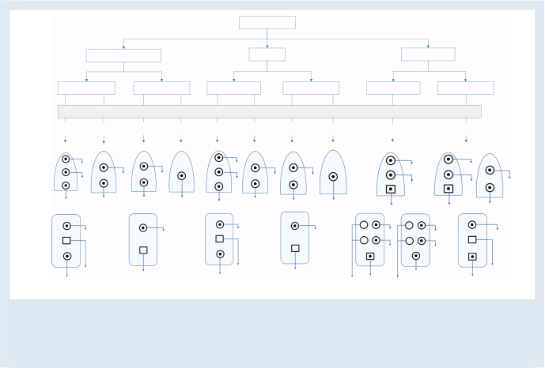
Indication

CSP-CRT
HOT/LOT-CRT
Anti-brady pacing

Sinus rhythm Permanent AF
Sinus rhythm Permanent AF
Sinus rhythm Permanent AF
Additional V lead?1
Y N Y N
Y N Y N
Y Y

IS-1 RA
IS-1 RA
IS-1 RA
IS-1 RA
IS-1 RA
IS-1 RA
IS-1 RA
IS-1 RA
IS-1 RA
IS-1 RV
A
IS-1 RV
A
A
IS-1 RA
CSP
IS-1 RV
IS-1 RV
IS-1 RV
PM
IS-1 RV A
IS-1 RV
CSP
IS-1 RV
IS-1 RV
A
CSP
IS-1 LV
IS-1 LV
IS-1 RV
CSP
RV
IS-4 LV
IS-4 RV
RV
CSP
RV
RV
CSP
CSP
CSP
CSP
LV
RV
CSP
LV#
CSP
LV#
DF-1 SVC IS-1 RA
DF-1 SVC IS-1 RA
IS-1 RA
IS-1 RA
IS-1 RA
IS-1 RA
IS-1 RA
DF-1 RV IS-1 RV
A
A
DF-4
ICD
CSP
A
DF-4
DF-4
DF-1 RV IS-1 RV
CSP
A
CSP
DF-4
DF-4
IS-1 LA
IS-1 LV
IS-4 LV
IS-1 LV
IS-4 LV
CSP
LV2

RV ICD Iead*
RV ICD Iead*
RV ICD lead* LV#
RV ICD Iead*
RV ICD Iead*
CSP
DF-1 ICD LV# RV pin capped
CSP
CSP
DF-1 ICD
RV pin capped
Figure 7 Device configuration for CSP according to device indication, underlying rhythm (i.e. requirement for an atrial lead), presence on an add- itional ventricular lead. In all cases with a CSP lead plugged to the RV port, adequate sensing must be ensured. Not shown here are additional config- urations with Y-adapters.1 Additional ventricular lead may be indicated for ICD therapy, backup pacing, adequate ventricular sensing, or CRT optimization.2 The LV lead is plugged to the RV port in case the CSP lead does not provide proper sensing (atrial or His potential oversensing and ventricular undersensing are issues that may be encountered with HBP). * DF-1 ICD lead may also be used; # IS-1 LV lead may also be used.

Funding
None declared.
Conflict of interest: H.B. has received speaker honoraria, consulting fees or institutional fellowship/research support from Abbot, Biotronik, Boston Scientific, Medtronic and Microport. C. I. has received speaker honoraria or consulting fees from Abbot, Biotronik, Boston Scientific, Medtronic and Microport, as well as research support from MicroPort. O.C. has received speaker honoraria and consulting fees from Biotronik, Boston Scientific and Medtronic K.C. has received speaker honoraria and consulting fees from Biotronik, Boston Scientific and Medtronic. J.D.P. reports speaker honoraria

and consultancy fees from Medtronic, Biotronik, Abbott and Boston Scientific. J.J. reports support from Medtronic (investigator-initiated exter- nal research grant) and Boston Scientific (consulting). K.V. has received speaker honoraria, consulting fees or institutional fellowship/research sup- port from Abbot, Boston Scientific, Medtronic and Microport. P.V. has the following declarations: Medtronic—Speaker, consultant, research and fel- lowship support; Abbott—consultant; Biotronik, Boston Scientific—hon- oraria; Patent- HBP delivery tool. Z.W. has received speaker honoraria, consulting fees or institutional fellowship/research support from Abbot, Boston Scientific, Medtronic. The other authors have not reported any disclosures.

Advices tables



General Considerations
Strength
Evidence
Advice TO DO
12-lead ECG should be recorded during
conduction system pacing implantation,
ideally using an electrophysiology recording system for simultaneous endocardial and ECG signals.
Endocavitary electrograms with minimally filtered signals showing current of injury should be displayed.4,5
May be Appropriate TO DO
If an EP recording system is not available, use of a 12-lead ECG with a pacing system analyzer for mapping endocardial signals may be
used.3
Advice NOT TO DO
OPN

OPN

OBS





CSP implantation should not be performed without a minimum display of ECG leads I, II, III, V1 and V5 or V6.
OPN
Advices Table 1 General considerations for CSP implantation

 | Strength of Advice  Clinical advice, based on robust published evidence  Clinical advice, based on consensus of the writing group  May be appropriate, based on published evidence  May be appropriate, based on consensus of the writing group  Areas of uncertainty  STRENGTH OF EVIDENCE  Randomized controlled trials Meta-analysis  Observational studies Expert opinion | Symbol  Abbreviation  RCT  META  OBS  OPN

Advices Table 2 HBP
His Bundle Pacing | Evidence |  | Strength
Advice TO DO  His bundle capture should always be confirmed at implantation and follow-up, using validated criteria7–10 such as transitions in QRS morphology with decrementing output / programmed stimulation and comparison of intervals from His potential and from pacing stimulus to V6 R-wave peak.  Screwing of the lead should be continued until significant torque buildup is felt to ensure lead stability  Lead stability should be routinely assessed11  May Be Appropriate TO DO  In case of infranodal conduction delay or block, pacing at 400ms or shorter cycle length showing 1:1 conduction without aberration should be tested.12  Lead rotations should be pursued until a His current of injury or deep negative morphology is observed, which predicts good electrical  13,14  parameters.  Unipolar His capture thresholds should be <2.5 V / 0.5ms but should ideally aim for ≤ 1.5V / 0.5ms. Bipolar sensing amplitude should be >2 mV (without atrial/His oversensing)  In the interest of safety, a backup ventricular lead can be useful in specific situations such as poor sensing, pacemaker-dependency, high-grade AVB, infranodal block, high pacing threshold and planned AVJ ablation.  Areas of uncertainty  Both selective as well as non-selective HBP are acceptable and probably have similar outcome although non-selective HBP provides the safety of ventricular backup capture and higher sensing amplitudes.15–18 | OBS  OPN  OBS  OBS  OBS  OPN  OPN  OBS |       

Advice Table 3 LBBAP
Left bundle branch area pacing  . . . . . |  | . . . . . . . . . . . .  . . . . . . . . . . . .                
Advice TO DO  Lead depth should be monitored using different techniques such as fluoroscopy, unipolar paced QRS morphology and impedance, fixation/ template beat morphology,39,40 presence of a fascicular potential,41 current of injury amplitude,4,5 contrast injection via the delivery catheter and capture by the ring electrode.  It is appropriate to evaluate and report presence or absence of conduction system capture using validated criteria42–44 such as transition in QRS morphology with decrementing output/programmed stimulation, V6RWPT, V6-V1 interpeak interval, comparison of intervals from intrinsic potential and from pacing stimulus to V6 R-wave peak.  Lead entanglement at the insertion site (characterized by torque build-up) or a “drill” effect during screwing (recognized by lack of lead progression on fluoroscopy and by pace-mapping despite lead rotations) should be recognized to avoid lead damage and dislodgement respectively.45  Acceptable thresholds for LBBAP capture are <1.5 V @ 0.5 ms (ideally<1 V @ 0.5 ms) and bipolar sensing should ideally be >4 mV.  May be appropriate TO DO  Lead insertion site is evaluated based upon fluoroscopy in the 20-30° right anterior oblique view at 15-35mm from the His bundle / tricuspid annulus and using pacemapping.1  The lead can be screwed into the interventricular septum at an angle of 10-40° superior to the horizontal plane in the left anterior oblique 30-40° view.  Advice NOT TO DO  In case of perforation of the septum, the lead should be repositioned at a new site and not simply withdrawn slightly.  Areas of uncertainty  It is unclear at this point if conduction system capture with left bundle branch area pacing is necessary to achieve good clinical outcome.46–51 | OBS  OBS  OBS  OPN  OBS  OBS  OPN  OBS

References
1. Liu X, Niu HX, Gu M, Chen X, Hu Y, Cai M et al. Contrast-enhanced image-guided lead deployment for left bundle branch pacing. Heart Rhythm 2021;18:1318–25.
2. Jastrzebski M, Kielbasa G, Moskal P, Bednarek A, Rajzer M, Curila K et al. Right bundle branch pacing: criteria, characteristics, and outcomes. Heart Rhythm 2023. doi: 10.1016/ j.hrthm.2023.01.017.
3. Jastrzebski M, Kielbasa G, Cano O, Curila K, Heckman L, De Pooter J et al. Left bundle branch area pacing outcomes: the multicentre European MELOS study. Eur Heart J 2022;43:4161–73.
4. Ponnusamy SS, Basil W, Vijayaraman P. Electrophysiological characteristics of septal perforation during left bundle branch pacing. Heart Rhythm 2022;19:728–34.
5. Shali S, Wu W, Bai J, Wang W, Qin S, Wang J et al. Current of injury is an indicator of lead depth and performance during left bundle branch pacing lead implantation. Heart Rhythm 2022;19:1281–8.
6. Burri H, Jastrzebski M, Vijayaraman P. Electrocardiographic analysis for his bundle pacing at implantation and follow-up. JACC Clin Electrophysiol 2020;6:883–900.
7. Jastrzebski M, Moskal P, Curila K, Fijorek K, Kukla P, Bednarek A et al. Electrocardiographic characterization of non-selective his-bundle pacing: validation of novel diagnostic criteria. Europace 2019;21:1857–64.

8. Jastrzebski M, Moskal P, Bednarek A, Kielbasa G, Vijayaraman P, Czarnecka D. His bun- dle has a shorter chronaxiethan does the adjacent ventricular myocardium: implications for pacemaker programming. Heart Rhythm 2019;16:1808–16.
9. Jastrzebski M, Moskal P, Bednarek A, Kielbasa G, Vijayaraman P, Czarnecka D. Programmed his bundle pacing. Circ Arrhythm Electrophysiol 2019;12:e007052.
10. Jastrzębski M, Moskal P, Kukla P, BednarekA, Kiełbasa G, Rajzer M et al. Novel approach to diagnosis of his bundle capture using individualized left ventricular lateral wall activa- tion time as reference. J Cardiovasc Electrophysiol 2021;32:3010–8.
11. Su L, Wu S, Wang S, Wang Z, Xiao F, Shan P et al. Pacing parameters and success rates of permanent his-bundle pacing in patients with narrow QRS: a single-centre experi- ence. Europace 2019;21:763–70.
12. Katritsis DG, Josephson ME. Electrophysiological testing for the investigation of brady- cardias. Arrhythm Electrophysiol Rev 2017;6:24–8.
13. Vijayaraman P, Dandamudi G, Worsnick S, Ellenbogen KA. Acute his-bundle injury cur- rent during permanent his-bundle pacing predicts excellent pacing outcomes. Pacing Clin Electrophysiol 2015;38:540–6.
14. Sato T, Soejima K, Maeda A, Mohri T, Tashiro M, Momose Y et al. Deep negative deflec- tion in unipolar his-bundle electrogram as a predictor of excellent his-bundle pacing threshold postimplant. Circ Arrhythm Electrophysiol 2019;12:e007415.

15. Bednarek A, Ionita O, Moskal P, Linkova H, Kiełbasa G, Prochazkova R et al.
Nonselective versus selective his bundle pacing: an acute intrapatient speckle-tracking strain echocardiographic study. J Cardiovasc Electrophysiol 2021;32:117–25.
16. Zhang J, Guo J, Hou X, Wang Y, Qian Z, Li K et al. Comparison of the effects of selective and non-selective his bundle pacing on cardiac electrical and mechanical synchrony. Europace 2018;20:1010–7.
17. Curila K, Prochazkova R, Jurak P, Jastrzebski M, HalamekJ, Moskal P et al. Both selective and nonselective his bundle, but not myocardial, pacing preserve ventricular electrical synchrony assessed by ultra-high-frequency ECG. Heart Rhythm 2020;17:607–14.
18. Beer D, Sharma PS, Subzposh FA, Naperkowski A, Pietrasik GM, Durr B et al. Clinical outcomes of selective versus nonselective his bundle pacing. JACC Clin Electrophysiol 2019;5:766–74.
19. Su L, Wang S, Wu S, Xu L, Huang Z, Chen X et al. Long-Term safety and feasibility of left bundle branch pacing in a large single-center study. Circ Arrhythm Electrophysiol 2021;14: e009261.
20. Padala SK, Master VM, Terricabras M, Chiocchini A, Garg A, Kron J et al. Initial experi- ence, safety, and feasibility of left bundle branch area pacing: A multicenter prospective study. JACC Clin Electrophysiol 2020;6:1773–82.
21. Hua W, Fan X, LiX, Niu H, Gu M, Ning X et al. Comparison of left bundle branch and his bundle pacing in bradycardia patients. JACC Clin Electrophysiol 2020;6:1291–9.
22. Vijayaraman P, Subzposh FA, Naperkowski A, Panikkath R, John K, Mascarenhas V et al.
Prospective evaluation of feasibility and electrophysiologic and echocardiographic char- acteristics of left bundle branch area pacing. Heart Rhythm 2019;16:1774–82.
23. De Pooter J, Calle S, Timmermans F, Van Heuverswyn F. Left bundle branch area pacing using stylet-driven pacing leads with a new delivery sheath: A comparison with lumen- less leads. J Cardiovasc Electrophysiol 2021;32:439–48.
24. Vijayaraman P, Ponnusamy S, Cano Ó, Sharma PS, Naperkowski A, Subsposh FA et al.
Left bundle branch area pacing for cardiac resynchronization therapy: results from the international LBBAP collaborative study group. JACC Clin Electrophysiol 2021;7:135–47.
25. Ponnusamy S, Basil W, Vijayaraman P. Electrophysiological characteristics of septal per- foration during left bundle branch pacing. Heart Rhythm 2022;19(5):728-734.
26. De Pooter J, Ozpak E, Calle S, Peytchev P, Heggermont W, Marchandise S et al. Initial experience of left bundle branch area pacing using stylet-driven pacing leads: A multicen- ter study. J Cardiovasc Electrophysiol 2022;33:1540–9.
27. Tan ESJ, Lee JY, Boey E, Soh R, Seow SC, Teo LJT et al. Predictors of loss of capture in left bundle branch pacing: a multicenter experience. Heart Rhythm 2022;19:1757–8.
28. Ponnusamy SS, Vijayaraman P. Aborted ST-elevation myocardial infarction-an unusual complication of left bundle branch pacing. HeartRhythm Case Rep 2020;6:520–2.
29. Molina-Lerma M, Tercedor-Sánchez L, Molina-Jiménez M, Álvarez M. Visualization of a septal perforator branch vein and coronary sinus during left bundle pacing implant. Eur Heart J Case Rep 2021;5:ytab049.
30. Zheng R, Wu S, Wang S, Su L, Ellenbogen KA, Huang W. Case report: interventricular septal hematoma complicating left bundle branch pacing lead implantation. Front Cardiovasc Med 2021;8:744079.
31. le Polain de Waroux JB, Wielandts JY, Gillis K, Hilfiker G, Sorgente A, Capulzini L et al.
Repositioning and extraction of stylet-driven pacing leads with extendable helix used for left bundle branch area pacing. J Cardiovasc Electrophysiol 2021;32:1464–6.
32. Tan ESJ, Lee JY, Boey E, Soh R, Sim MG, Yeo WT et al. Use of extendable helix leads for conduction system pacing: differences in lead handling and performance lead design im- pacts conduction system pacing. J Cardiovasc Electrophysiol 2022;33:1550–7.
33. Chen X, Wei L, Bai J, Wang W, Qin S, Wang J et al. Procedure-Related complications of left bundle branch pacing: A single-center experience. Front Cardiovasc Med 2021;8: 645947.
34. Ravi V, Larsen T, Ooms S, Trohman R, Sharma PS. Late-onset interventricular septal perforation from left bundle branch pacing. HeartRhythm Case Rep 2020;6:627–31.
35. Li X, Zhu H, Fan X, Wang Q, Wang Z, Li H et al. Tricuspid regurgitation outcomes in left bundle branch area pacing and comparison with right ventricular septal pacing. Heart Rhythm 2022;19:1202–3.
36. Hu Q, You H, Chen K, Dai Y, Lu W, Li Y et al. Distance between the lead-implanted site and tricuspid valve annulus in patients with left bundle branch pacing: effects on postoperative tricuspid regurgitation deterioration. Heart Rhythm 2023;20: 217–23.

37. Sharma PS, Patel NR, Ravi V, Zalavadia DV, Dommaraju S, Garg V et al. Clinical outcomes of left bundle branch area pacing compared to right ventricular pacing: results from the geisinger-rush conduction system pacing registry. Heart Rhythm 2022;19:3–11.
38. Ponnusamy SS, Vijayaraman P. Late dislodgement of left bundle branch pacing lead and successful extraction. J Cardiovasc Electrophysiol 2021;32:2346–9.
39. Ponnusamy SS, Ganesan V, Syed T, Balasubramanian S, Vijayaraman P. Template beat: A novel marker for left bundle branch capture during physiological pacing. Circ Arrhythm Electrophysiol 2021;14:e009677.
40. Ponnusamy SS, Basil W, Vijayaraman P. M-beat-A novel marker for selective left bundle branch capture. J Cardiovasc Electrophysiol 2022;33:1888–92.
41. Su L, Xu T, Cai M, Xu L, Vijayaraman P, Sharma PS et al. Electrophysiological character- istics and clinical values of left bundle branch current of injury in left bundle branch pa- cing. J Cardiovasc Electrophysiol 2020;31:834–42.
42. Jastrzębski M, Burri H, Kiełbasa G, Curila K, Moskal P, Bednarek A et al. The V6-V1 in- terpeak interval: a novel criterion for the diagnosis of left bundle branch capture. Europace 2022;24:40–7.
43. Jastrzębski M, Kiełbasa G, Curila K, Moskal P, Bednarek A, Rajzer M et al.
Physiology-based electrocardiographic criteria for left bundle branch capture. Heart Rhythm 2021;18:935–43.
44. Jastrzębski M, Moskal P, Bednarek A, Kiełbasa G, Kusiak A, Sondej T et al. Programmed deep septal stimulation: A novel maneuver for the diagnosis of left bundle branch cap- ture during permanent pacing. J Cardiovasc Electrophysiol 2020;31:485–93.
45. Jastrzebski M, Moskal P, Holda MK, Strona M, Bednarek A, Kielbasa G et al. Deep septal deployment of a thin, lumenless pacing lead: a translational cadaver simulation study. Europace 2020;22:156–61.
46. Curila K, Jurak P, Jastrzebski M, Prinzen F, Waldauf P, Halamek J et al. Left bundle branch pacing compared to left ventricular septal myocardial pacing increases interventricular dyssynchrony but accelerates left ventricular lateral wall depolarization. Heart Rhythm 2021;18:1281–9.
47. Curila K, Jurak P, Vernooy K, Jastrzebski M, Waldauf P, Prinzen F et al. Left ventricular myocardial septal pacing in close proximity to LBB does not prolong the duration of the left ventricular lateral wall depolarization compared to LBB pacing. Front Cardiovasc Med 2021;8:787414.
48. Heckman LIB, Luermans J, Curila K, Van Stipdonk AMW, Westra S, Smisek R et al. Comparing ventricular synchrony in left bundle branch and left ventricular septal pacing in pacemaker patients. J Clin Med 2021;10:822.
49. Mirolo A, Chaumont C, Auquier N, Savoure A, Godin B, Vandevelde F et al. Left bundle branch area pacing in patients with baseline narrow, left, or right bundle branch block QRS patterns: insights into electrocardiographic and echocardiographic features. Europace 2023;25:526–35.
50. Wu S, Sharma PS, Huang W. Novel left ventricular cardiac synchronization: left ven- tricular septal pacing or left bundle branch pacing? Europace 2020;22:ii10–8.
51. Hou X, Qian Z, Wang Y, Qiu Y, Chen X, Jiang H et al. Feasibility and cardiac synchrony of permanent left bundle branch pacing through the interventricular septum. Europace 2019;21:1694–702.
52. Vijayaraman P, Subzposh FA, Naperkowski A. Extraction of the permanent his bundle pacing lead: safety outcomes and feasibility of reimplantation. Heart Rhythm 2019;16: 1196–203.
53. Migliore F, Dall’Aglio P, Falzone PV, Bertaglia E, Zanon F. Extraction of a very old his bundle pacing lead: A safe and effective procedure? Pacing Clin Electrophysiol 2021;44: 1464–5.
54. Teigeler T, KolominskyJ, Vo C, Shepard RK, Kalahasty G, Kron J et al. Intermediate-term performance and safety of his-bundle pacing leads: A single-center experience. Heart Rhythm 2021;18:743–9.
55. Zweerink A, Bakelants E, Stettler C, Burri H. Cryoablation vs. Radiofrequency ablation of the atrioventricular node in patients with his-bundle pacing. Europace 2021;23: 421–30.
56. Vijayaraman P, Subzposh FA, Naperkowski A. Atrioventricular node ablation and his bundle pacing. Europace 2017;19:iv10–6.
57. Su L, Cai M, Wu S, Wang S, Xu T, Vijayaraman P et al. Long-term performance and risk factors analysis after permanent his-bundle pacing and atrioventricular node ablation in patients with atrial fibrillation and heart failure. Europace 2020;22:ii19–26.

